Grade:IV Estimating Sums and Differences

For estimating sums and differences in the number we use the rounded numbers for estimations to its nearest tens, hundred, and thousand.
Estimating Sums:
In many practical calculations, only an approximation is required rather than an exact answer. To do this, numbers are rounded off to a given place value of ten, hundred, thousand ...
Example on Estimating Sums:
1. There are 74 coconut cookies and 48 chocolate cookies in a jar. Estimate the total number of cookies.
Round the numbers to the nearest ten and add.
Rounded to TENS
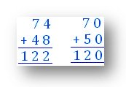
There are approximately 120 cookies.
The actual number of cookies is 122.
The estimate differs from the actual by 2.

2. There are 275 students in class IVth and 238 students in class Vth. Estimate the total number of students in the two classes.
We can round the numbers either to the nearest ten or the nearest hundred and add to get an estimate.
Rounded to TENS
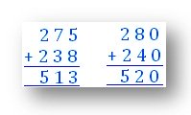
There are approximately 520 students.
The estimate differs from the actual by 7.
Rounded to HUNDREDS
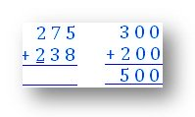
There are approximately 500 students.
The estimate differs from the actual by 13.
Estimating Difference:
Example on Estimating Difference:
The school library has 284 science books and 268 social sciences books.
Estimate the difference in the number of books.
Rounded to TENS
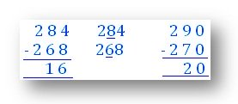
The difference is approximately 20 books.
The estimate differs from the actual number by 4.
Rounded to HUNDREDS
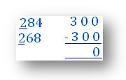
In this case, rounding number to hundreds will not be meaningful as the difference will be 0.

